Time Trial Information (Woodgreen Course)

IMPORTANT REGULATION CHANGES FOR ALL EVENTS HELD AT WOODGREEN.

Recently at the request of the PSNI all promoters of events at Woodgreen had to agree to the following safety rules. It is not the job of the promoters to enforce these, as we have an event to run, but we would appreciate your co-operation as non compliance will simply mean exclusion of all events on this course.

Sign on will no longer be held at the lay-by, but at the following location.
Sign on location for Woodgreen
http://www.translink.co.uk/Services/Other-Translink-Services/Park--Ride/Park--Ride-Locations/ballee/
or BT42 2HD for your satnav

Parking at the start Lay-by is strictly only for the Organisers Marshalls and timekeepers. You MUST ride to the start from the sign on area, your time will NOT be recorded if you ignore this.

- No working rear light, No Start!!!!

- Times will be relayed back to the sign on area, results will be published at event finish.

- DO NOT disturb the timekeeper and return all numbers to the sign on area.

- Only 1 event per week will be held on this course, the organisers of the promoting clubs are aware of this and have juggled the calendar to comply.

- In the event of fading light or heavy rainfall, the organiser reserve the right to cancel the event.

Map of Woodgreen 10 TT
http://www.mapmyride.com/gb/ballymena-nir/01-10-woodgreen-route-1159557
Course travels south towards the motorway flyover and does 1 complete lap of the flyover and heads back north towards Ballymena. 5 miles out and back

General league Regulations and requirements.

- Treat all officials, timekeepers and fellow riders with respect if you wish to return.

- A rear light is compulsory. You will not be allowed to start without an effective rear light.

- Normal high way code rules apply- i.e. caution at roundabouts.

- No drafting, of other riders or vehicles. No rider support is required, thus no vehicles associated with riders will be allowed on course as they can interfere with the event. Spectators are not permitted to follow competitors. They can cause tailbacks or create a slipstream for riders.

- Do not disturb the timekeeper under any circumstances, they have an even more difficult task than the rider. To assist the time keeper, always wear the number as shown below. It must be worn on the left arm, take care it doesn't bunch up. Remember it must face the front to allow the timekeeper to identify you as you approach. Not to the side. Always shout your number as you approach to assist the spotters and timekeeper. It is YOUR responsibility to do this, if we can't identify you we can't give you a time. (See figure 2)
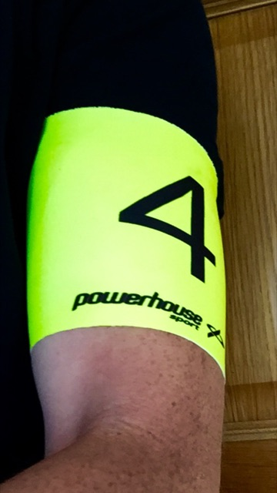

(Figure 2)

- return numbers to the sign on area, where results can be viewed. There will be a box provided for this purpose. If you accidentally leave with the number. Contact us to return it via post.
- No warming up on the course once the event starts. There are suitable side roads to do this if required, or if needed do it at the opposite end of the course, not crossing the start finish line.

- If 1 rider misses their start, it creates work for the officials to edit their mistake. Help us to help you.

- Typically timing errors occur only when riders start out of sequence, or fail to identify themselves. Any irregularities will be picked up by out team and verified with the finish line camera.

- Although riders are legally entitled to use the same width of roadway as a car, in the interest of good relations with other road users it is recommended that they keep within the area indicated by the red line in the picture. There will be observers to assess behaviour of competitors and those who consistently breach race recommendations will risk disqualification and exclusion from the remaining races in the series. (See Figure below)

